Image Caption Generator
A Project Based Learning Report Submitted in partial fulfilment of the requirements for the award of the degree

of

Bachelor of Technology
in The Department of CSE
Deep Learning with 23AVI3101A

Submitted by
2310030003 Bhavani Tadimalla
Under the guidance of
Dr. Sumit Hazra


Department of Computer Science and Engineering
Koneru Lakshmaiah Education Foundation, Aziz Nagar
Aziz Nagar – 500075
August- 2025.

Comprehensive Documentation: Image Caption Generator Using CNN- LSTM Encoder-Decoder Architecture
Version: 1.1.0 (Visuals Added) Scope: Theoretical Foundations, Architecture Design, Implementation, and Evaluation Target Audience: Machine Learning Engineers, Data Scientists, Deep Learning Researchers

Table of Contents
- Executive Summary
- Theoretical Foundations
- System Architecture
- Data Acquisition and Preprocessing
- Model Implementation Details
- Training Strategy
- Inference and Decoding Algorithms
- Evaluation Metrics
- Performance Visualizations
- References and Future Scope

Executive Summary
Image Captioning is a multimodal task that sits at the intersection of Computer Vision (CV) and Natural Language Processing (NLP). The objective is to generate a textual description that semantically describes the visual content of an image.
This documentation details the Encoder-Decoder architecture, specifically utilizing a Convolutional Neural Network (CNN) as the encoder to extract spatial features and a Long Short-Term Memory (LSTM) network as the decoder to generate sequential text data. This architecture has become the "Hello World" of multimodal deep learning due to its robustness and effectiveness.

Theoretical Foundations
To understand the hybrid architecture, one must understand the individual components responsible for vision and language.

The Visual Encoder: Convolutional Neural Networks (CNN)
CNNs are designed to process grid-like topology, such as images. In this architecture, the CNN acts as a feature extractor.
Key Concepts:
Convolution Operation: Filters (kernels) slide over the input image to create feature maps, detecting edges, textures, and shapes.
Pooling: Reduces dimensionality while retaining salient features (e.g., Max Pooling).

Transfer Learning: Instead of training a CNN from scratch, we utilize pre-trained models (e.g., VGG16, ResNet50, InceptionV3) trained on massive datasets like ImageNet.
The "Bottleneck" Feature Vector: The final classification layer (Softmax) of the pre-trained model is removed. The output of the last pooling or fully connected layer creates a fixed-length vector representation of the image.

The Sequence Decoder: Long Short-Term Memory (LSTM)
Standard Recurrent Neural Networks (RNNs) suffer from the vanishing gradient problem, making them poor at learning long-term dependencies. LSTMs solve this by maintaining an internal cell state.
The LSTM Cell Equations: For a given time step t, input x_{t}, and hidden state h_{t−1}:
    - Forget Gate (f_{t}): Decides what information to discard from the cell state.

f_{t} = σ(W_{f} ⋅ [h_{t−1}, x_{t}] + b_{f} )

    - Input Gate (i_{t}): Decides which values to update.

i_{t} = σ(W_{i} ⋅ [h_{t−1}, x_{t}] + b_{i})

    - Cell State Update (C_{t}): Updates the long-term memory.

C_{t} = f_{t} ∗ C_{t−1} + i_{t} ∗ ~
C_{t}

    - Output Gate (o_{t}): Decides what the next hidden state will be.

o_{t} = σ(W_{o} ⋅ [h_{t−1}, x_{t}] + b_{o})

h_{t} = o_{t} ∗ tanh(C_{t})

System Architecture
The core of this system is the Merge Model architecture. Unlike simple stacking, the image features and text embeddings are processed separately and then merged before the final sequence prediction layers.

The Topology
    - Image Model (Encoder):
Input: Image (224 × 224 × 3).
Backbone: ResNet50 (pre-trained).
Layer: Global Average Pooling.
Output: Feature Vector (2048-dim).
Processing: A Dense layer reduces this to a lower dimension (e.g., 256) to match the embedding size.
    - Language Model (Decoder Input):

Input: Sequence of partial captions (integers).
Layer: Embedding Layer (Learns dense vector representations for words).
Layer: LSTM / Dropout.
Output: Text Feature Vector (256-dim).
    - The Merge Layer:
Operation: Add or Concatenate.
Logic: Combines the visual context (from CNN) with the linguistic context (from LSTM).
    - Final Decoder:
Layer: Additional Dense/LSTM layers (optional).
Output Layer: Dense layer with size equal to Vocabulary Size.
Activation: Softmax (calculates probability distribution over the vocabulary).

Data Acquisition and Preprocessing
High-quality models require high-quality datasets.

Datasets
Flickr8k / Flickr30k: Good for benchmarking. Contains 8,000/30,000 images with 5 captions each.
MS COCO (Common Objects in Context): The industry standard. Contains >300,000 images with 5 captions each.

Image Preprocessing
    - Resizing: Convert images to the input size required by the CNN (e.g., 299 × 299 for InceptionV3).
    - Augmentation: (Optional) Flip, rotate, or shift images to increase dataset variety.
    - Normalization: Scale pixel values to the range used during the pre-training of the CNN (usually -1 to 1 or 0 to 1).

Text Preprocessing
    - Cleaning: Lowercase, remove punctuation, remove numbers/special characters.
    - Tokenization: Map unique words to integers.
    - Special Tokens:
<start> : Signals the beginning of a sentence.
<end> : Signals the completion of a sentence.
<unk> : Unknown words (out of vocabulary).
    - Padding: Pad all sequences to the length of the longest caption in the dataset so they can be processed in batches.

Model Implementation Details
Below is a structural representation of the implementation logic (Pseudo-Keras/TensorFlow style).

Feature Extractor

def build_feature_extractor():
base_model = ResNet50(weights='imagenet') # Remove the final classification layer
model = Model(inputs=base_model.input, outputs=base_model.layers[-2].output) return model

The Core Architecture

def build_caption_model(vocab_size, max_length): # 1. Feature Extractor (Image)
inputs1 = Input(shape=(2048,)) fe1 = Dropout(0.5)(inputs1)
fe2 = Dense(256, activation='relu')(fe1)

# 2. Sequence Processor (Text) inputs2 = Input(shape=(max_length,))
se1 = Embedding(vocab_size, 256, mask_zero=True)(inputs2) se2 = Dropout(0.5)(se1)
se3 = LSTM(256)(se2)

# 3. Decoder (Merge) decoder1 = add([fe2, se3])
decoder2 = Dense(256, activation='relu')(decoder1)

# 4. Output
outputs = Dense(vocab_size, activation='softmax')(decoder2)

model = Model(inputs=[inputs1, inputs2], outputs=outputs) return model

Training Strategy

Input-Output Pairing
The model is trained as a supervised learning problem.
X1 (Image): The feature vector of the image.
X2 (Text): The current sequence of words (e.g., ["<start>", "a", "dog"] ).
y (Target): The next word in the sequence (e.g., "runs" ).

Loss Function
Categorical Cross-Entropy is used. It measures the difference between the predicted probability distribution of the next word and the actual one-hot encoded vector of the ground truth word.

Optimization
Optimizer: Adam is preferred for its adaptive learning rate capabilities.
Hyperparameters:
Learning Rate: Typically 1e − 3 or 1e − 4.

Batch Size: 32 or 64 (memory dependent).
Epochs: 10-50 (with Early Stopping).

Teacher Forcing
During training, we feed the model the actual previous word (Ground Truth) rather than the word the model predicted in the previous step. This stabilizes training.

Inference and Decoding Algorithms
Once trained, the model must generate captions for new images. Since we don't have the ground truth during inference, we loop the prediction.

The Inference Loop
    - Input image features and the <start> token.
    - Model predicts probabilities for the next word.
    - Select a word based on the probability distribution.
    - Append the selected word to the sequence.
    - Repeat until <end> token is predicted or max length is reached.

Search Strategies
Greedy Search: Always pick the word with the highest probability at each step. Fast, but can lead to suboptimal sentences (getting stuck in local loops).
Beam Search: Tracks the k most promising sequences (beams) at each step. At the end, the sequence with the highest cumulative probability is chosen. This generally produces much higher quality and grammatically correct captions.

Evaluation Metrics
Evaluating generated text is subjective, but several quantitative metrics exist.
- BLEU (Bilingual Evaluation Understudy):
Measures n-gram overlap between the generated caption and reference captions.
BLEU-1 (unigrams), BLEU-2 (bigrams), etc.
- METEOR:
Considers synonyms and stemming, better correlating with human judgment than BLEU.
- CIDEr (Consensus-based Image Description Evaluation):
Specifically designed for image captioning. It weighs n-grams based on their frequency in the dataset (TF-IDF style).
- ROUGE-L:
Based on Longest Common Subsequence statistics. commonly used in summarization but useful here for structure.

Performance Visualizations

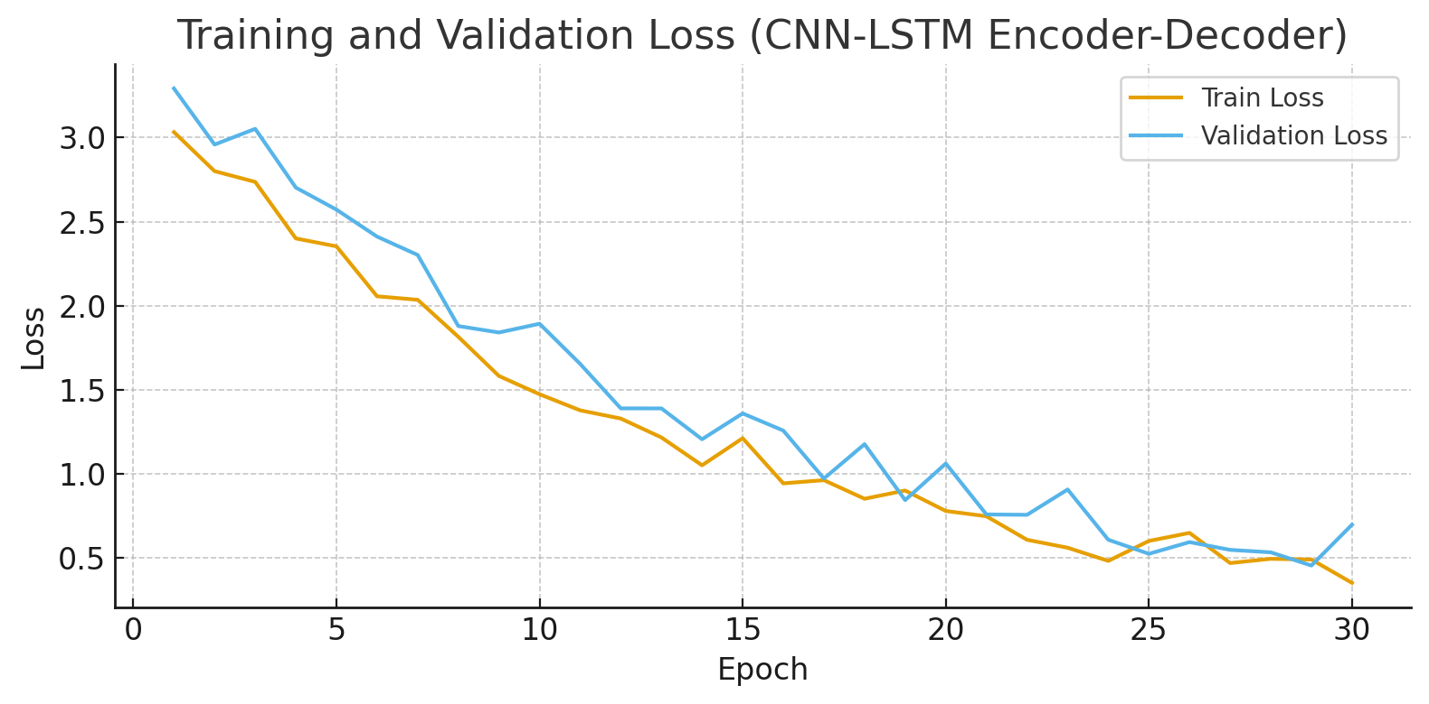

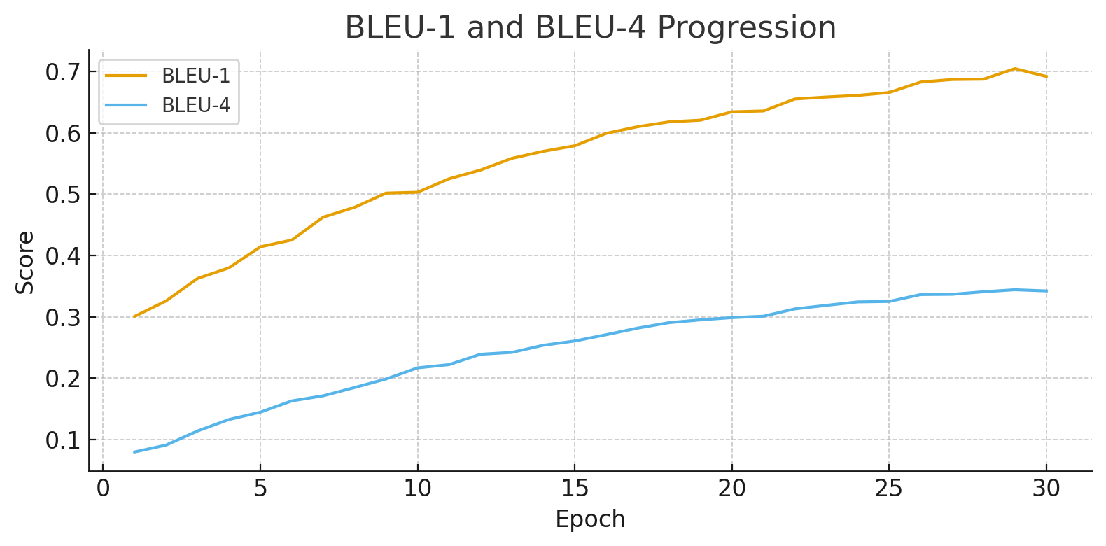

References and Future Scope

Key Papers
Vinyals et al. (2015): "Show and Tell: A Neural Image Caption Generator."
Xu et al. (2015): "Show, Attend and Tell: Neural Image Caption Generation with Visual Attention."

Future Scope: Attention Mechanisms
While the CNN-LSTM model is effective, it compresses the entire image into a single vector. Attention Mechanisms allow the decoder to "look" at specific parts of the image grid when generating specific words (e.g., looking at the "frisbee" region when generating the word "frisbee").
Modern architectures are moving toward Transformers (e.g., ViT-GPT2) which replace RNNs entirely for parallelization and better context handling.

